1. **为什么2015年以前的plot波动那么大？**

因为之前的HF个数太少了，下图中，2015年之前接近与0

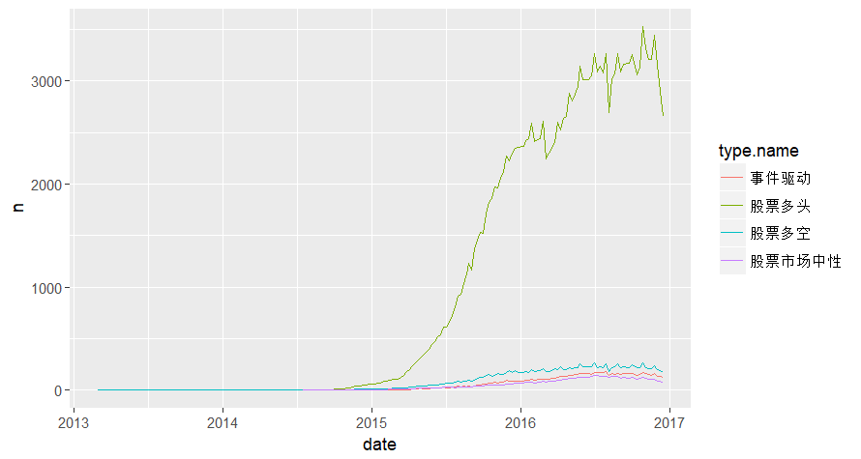

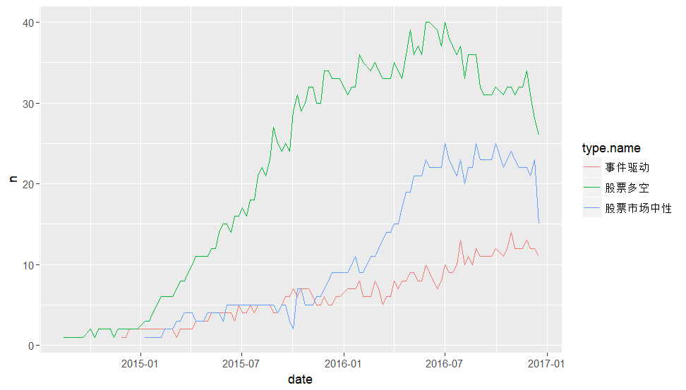

1. **什么导致了winner和loser的不同？**

可能的原因是**存续期**不同：

* winner：存续期越长收益越高
* loser：存续期越短收益越高

**股票多头**

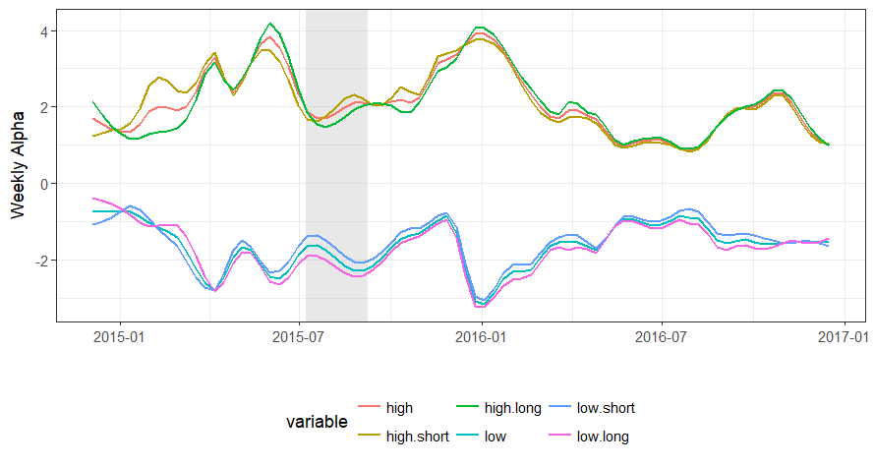

**Notes:** high and low indicate winner and loser respectively, while short and long indicate if the fund’s life in this group is below or above the median life. So “low.short” means losers whose life is shorter than the median.

**股票多空**

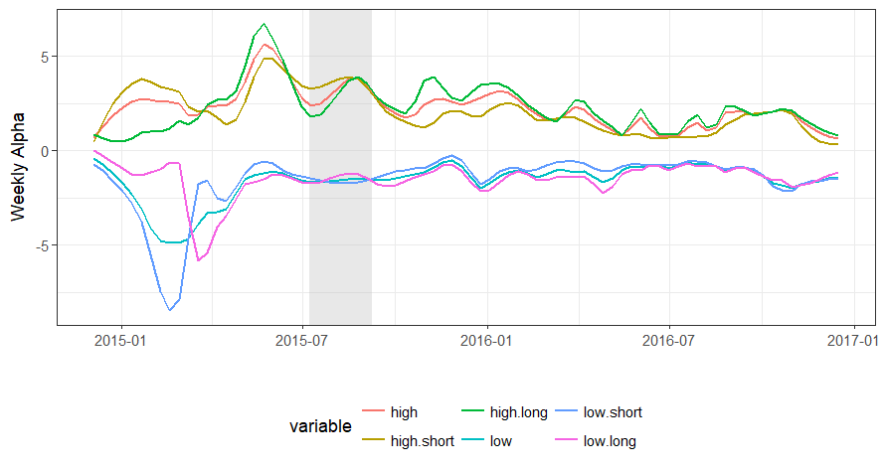

**股票市场中性**

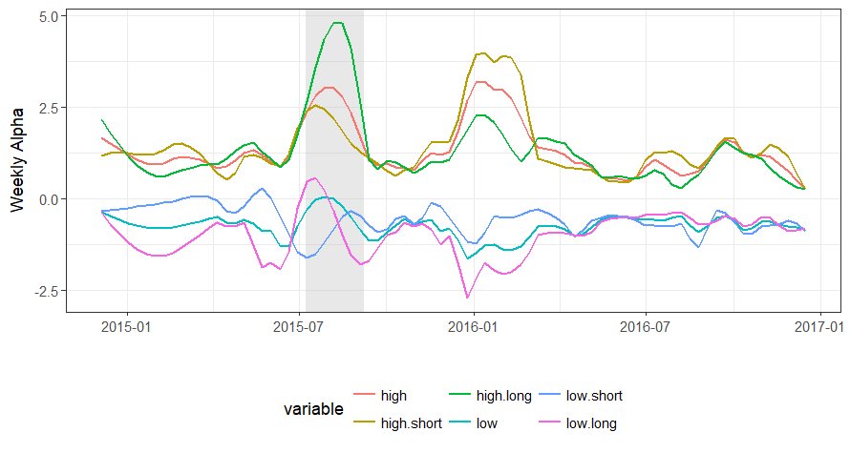

**I add five new strategies:** "债券基金", "混合策略", "套利策略", "宏观策略", "定向增发"

**Before and After restriction (w/o dummy)**

|  |  |  |  |  |  |  |  |  |
| --- | --- | --- | --- | --- | --- | --- | --- | --- |
|  | **Full Sample** | | **Long** | | **Long & Short** | | **Market Neutral** | |
|  | **Before** | **After** | **Before** | **After** | **Before** | **After** | **Before** | **After** |
| Alpha | 0.123*** | 0.106** | 0.077** | 0.133** | 0.234*** | 0.132* | 0.058 | 0.052* |
|  | (0.031) | (0.035) | (0.029) | (0.046) | (0.046) | (0.050) | (0.031) | (0.022) |
| Market | 0.227*** | 0.141*** | 0.422*** | 0.242*** | 0.218*** | 0.125*** | 0.040*** | 0.055*** |
|  | (0.010) | (0.010) | (0.009) | (0.013) | (0.014) | (0.014) | (0.010) | (0.006) |
| SMB | 0.091*** | -0.027 | 0.065** | -0.040 | 0.019 | -0.033 | 0.189*** | -0.008 |
|  | (0.022) | (0.022) | (0.020) | (0.029) | (0.033) | (0.031) | (0.022) | (0.014) |
| HML | -0.059** | -0.005 | -0.106*** | -0.021 | -0.037 | 0.004 | -0.033 | 0.001 |
|  | (0.022) | (0.026) | (0.021) | (0.036) | (0.033) | (0.038) | (0.022) | (0.017) |
| UMD | 0.012 | 0.072*** | 0.025* | 0.110*** | -0.011 | 0.065* | 0.022 | 0.040** |
|  | (0.013) | (0.019) | (0.012) | (0.026) | (0.019) | (0.028) | (0.013) | (0.012) |
| Adj. R2 | 0.574 | 0.637 | 0.937 | 0.899 | 0.590 | 0.651 | 0.532 | 0.685 |

**Before and After restriction**

|  |  |  |  |  |  |  |  |  |  |  |
| --- | --- | --- | --- | --- | --- | --- | --- | --- | --- | --- |
|  | **债券基金** | | **混合策略** | | **套利策略** | | **宏观策略** | | **定向增发** | |
|  | **Before** | **After** | **Before** | **After** | **Before** | **After** | **Before** | **After** | **Before** | **After** |
| Alpha | 0.164*** | 0.317* | 0.223*** | 0.179* | 0.187*** | 0.055* | 0.451*** | 0.193* | 0.295*** | 0.353** |
|  | (0.028) | (0.147) | (0.055) | (0.072) | (0.030) | (0.024) | (0.114) | (0.080) | (0.075) | (0.110) |
| Market | 0.020* | 0.073 | 0.268*** | 0.153*** | 0.059*** | 0.023** | 0.172*** | 0.133*** | 0.429*** | 0.255*** |
|  | (0.009) | (0.042) | (0.017) | (0.020) | (0.009) | (0.007) | (0.035) | (0.023) | (0.023) | (0.031) |
| SMB | 0.013 | -0.145 | -0.012 | -0.070 | 0.012 | 0.001 | 0.049 | -0.019 | 0.053 | -0.204** |
|  | (0.020) | (0.092) | (0.039) | (0.045) | (0.022) | (0.015) | (0.081) | (0.050) | (0.054) | (0.069) |
| HML | 0.005 | -0.187 | -0.119** | -0.060 | 0.008 | 0.001 | 0.076 | 0.036 | -0.216*** | -0.183* |
|  | (0.020) | (0.113) | (0.040) | (0.055) | (0.022) | (0.018) | (0.082) | (0.061) | (0.054) | (0.085) |
| UMD | 0.003 | -0.109 | 0.002 | 0.084* | -0.001 | -0.018 | -0.010 | 0.059 | -0.127*** | 0.131* |
|  | (0.012) | (0.082) | (0.023) | (0.040) | (0.013) | (0.013) | (0.048) | (0.045) | (0.032) | (0.061) |
| Adj. R2 | 0.018 | 0.026 | 0.609 | 0.582 | 0.188 | 0.171 | 0.119 | 0.427 | 0.694 | 0.609 |

**Before and After restriction (w/ dummy)**

|  |  |  |  |  |  |  |  |  |  |
| --- | --- | --- | --- | --- | --- | --- | --- | --- | --- |
|  | **Full Sample** | **Long** | **Long & Short** | **Market Neutral** | **债券基金** | **多策略** | **套利策略** | **宏观策略** | **定向增发** |
| Alpha | 0.176*** | 0.153*** | 0.272*** | 0.103*** | 0.177*** | 0.269*** | 0.199*** | 0.472*** | 0.394*** |
|  | (0.029) | (0.039) | (0.043) | (0.030) | (0.049) | (0.053) | (0.027) | (0.098) | (0.078) |
| Market | 0.192*** | 0.357*** | 0.186*** | 0.034*** | 0.032* | 0.228*** | 0.046*** | 0.159*** | 0.365*** |
|  | (0.008) | (0.010) | (0.011) | (0.008) | (0.013) | (0.014) | (0.007) | (0.026) | (0.021) |
| SMB | 0.026 | -0.014 | -0.021 | 0.112*** | -0.023 | -0.060 | 0.003 | 0.018 | -0.082 |
|  | (0.018) | (0.024) | (0.026) | (0.018) | (0.029) | (0.032) | (0.016) | (0.059) | (0.047) |
| HML | -0.045* | -0.082** | -0.027 | -0.026 | -0.036 | -0.104** | 0.009 | 0.065 | -0.213*** |
|  | (0.019) | (0.025) | (0.028) | (0.020) | (0.032) | (0.034) | (0.017) | (0.063) | (0.051) |
| UMD | 0.023* | 0.039* | 0.001 | 0.030* | -0.011 | 0.015 | -0.004 | 0.002 | -0.082** |
|  | (0.012) | (0.016) | (0.017) | (0.012) | (0.019) | (0.021) | (0.011) | (0.039) | (0.031) |
| After | -0.131* | -0.072 | -0.175* | -0.144* | 0.087 | -0.127 | -0.142** | -0.328 | -0.216 |
|  | (0.055) | (0.073) | (0.080) | (0.056) | (0.091) | (0.099) | (0.049) | (0.182) | (0.146) |
| Adj. R2 | 0.533 | 0.858 | 0.561 | 0.413 | 0.013 | 0.564 | 0.189 | 0.157 | 0.607 |